* **UFT Assignment Scope:**

Write a UFT Automation code for the Flight GUI on the Micro Focus application:

1. In Windows, click on Start in the lower left corner of your screen.
2. Scroll down to the Micro Focus Group and expand the list
3. Select the Flight GUI application as shown below.

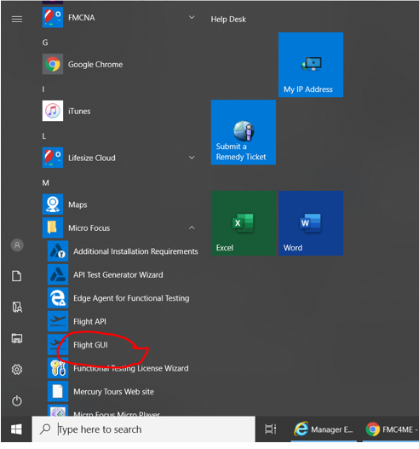

* The following dialog box will be displayed

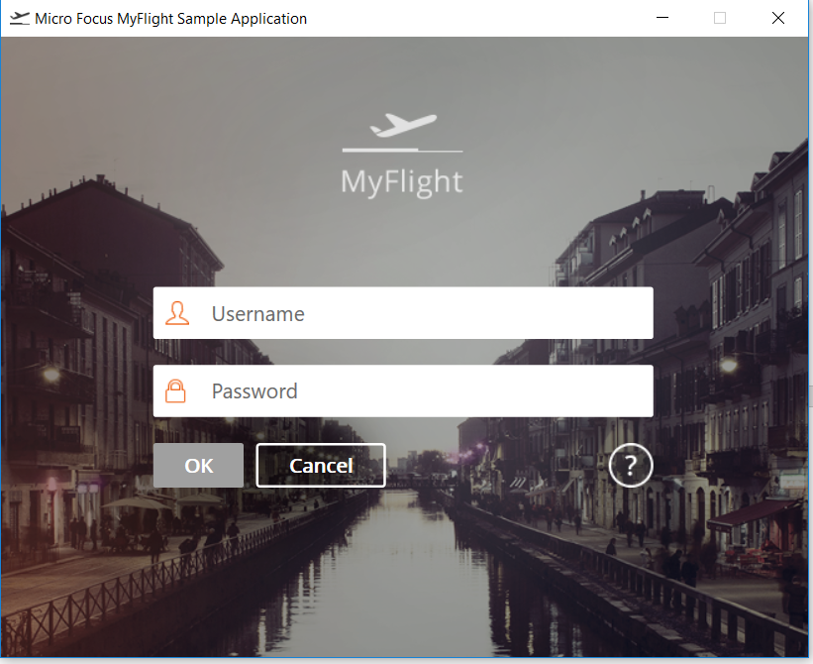

* Login with the **User id: John, Password: HP**

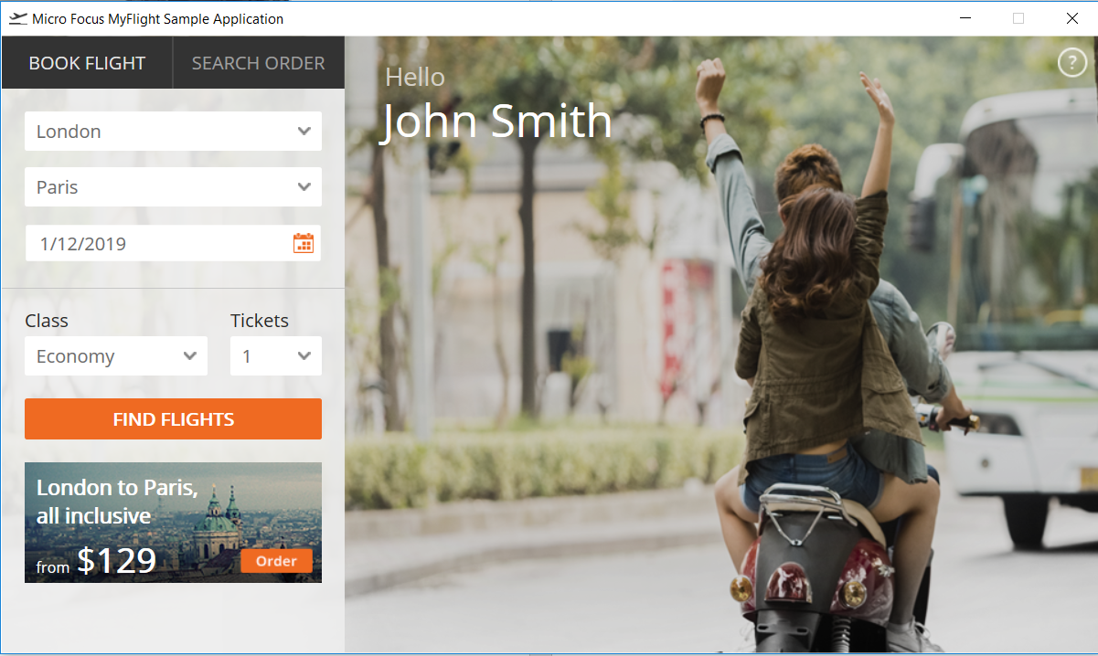

* Book a flight for a City and a Date.
* Select a Class and number of passengers for this flight.

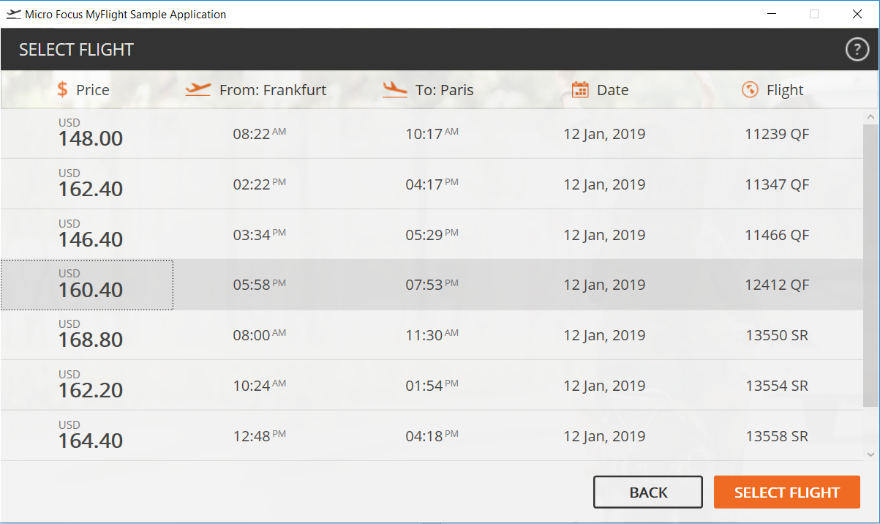

* Select a flight option and then press the SELECT FLIGHT button.
* The following screen is displayed.

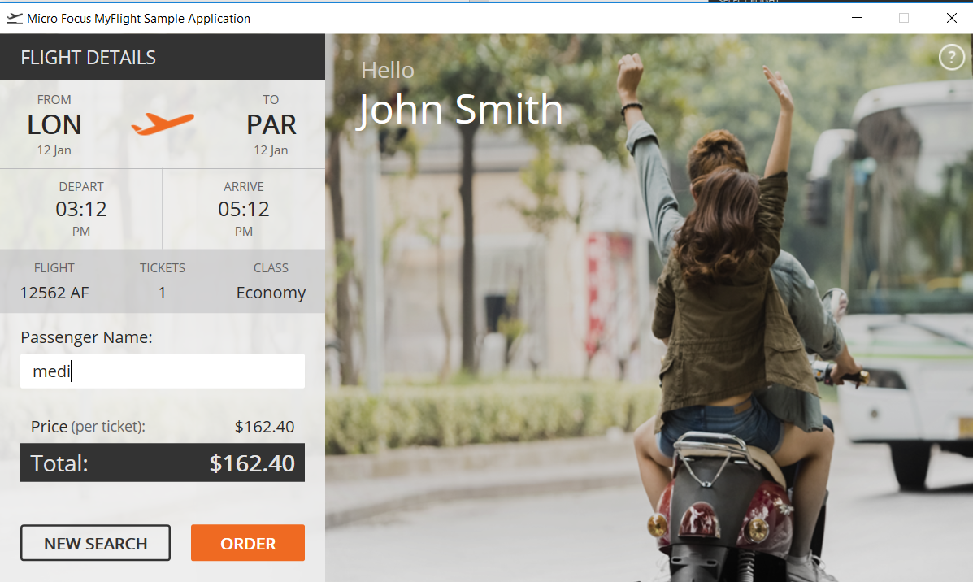

* Verify that the information on the screen is correct. Meaning it is the right selection.
* Enter the passenger name(s).
* Select ORDER to select the flight.
* Repeat this 3 times for 3 different Flights for different Cities and different Classes, and Passenger names.

**The UFT Project Requirements**

1. To start the application, in Windows click on Start -> Micro Focus -> Flight GUI.
2. The use of **the Object Repository** is required.
3. You can record your script, but I would like you to add one object manually to the Object Repository and then insert the associated line of the code in the script manually.
4. Have 2 **CheckPoints** in the script.
5. All of the entries in the fields should be data-driven from the Data Table.
6. Enter legible and meaningful test data values.
7. Take screenshots of every new window.

**Take screenshots of the windows BEFORE and AFTER filling out the forms. Show a few samples of them during your presentation.**

1. The script has to repeat 3 times for 3 different data rows in the data sheet for 3 different reservations.
2. You will run your script live during class and show the results of your test in UFT.

**Extra credit**

1. Run the UFT automation using the Windows scheduler.

**Team Presentation**

1. Select one representative from your group that will demo the script in the class.

2. All of the team members in the group have to directly participate in the project and be at the presentation. Questions will be asked from everyone on the team about the script and how it was put together.

**NOTE:** YOU HAVE TO MAKE SURE THAT YOUR SCRIPT WILL RUN PERFECTLY DURING YOUR PRESENTATION.